**MFS60A – MAKOCRAFT 481 SUV**

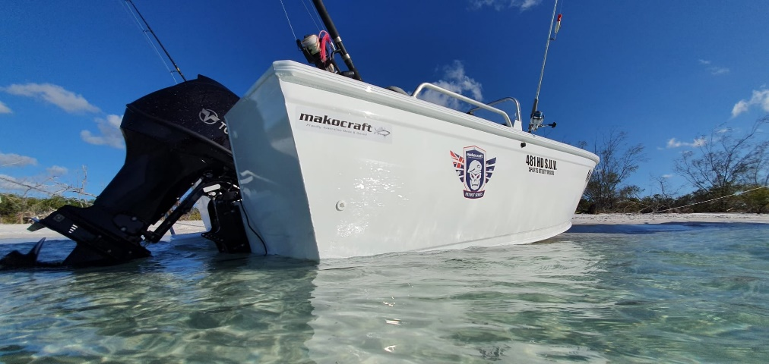 

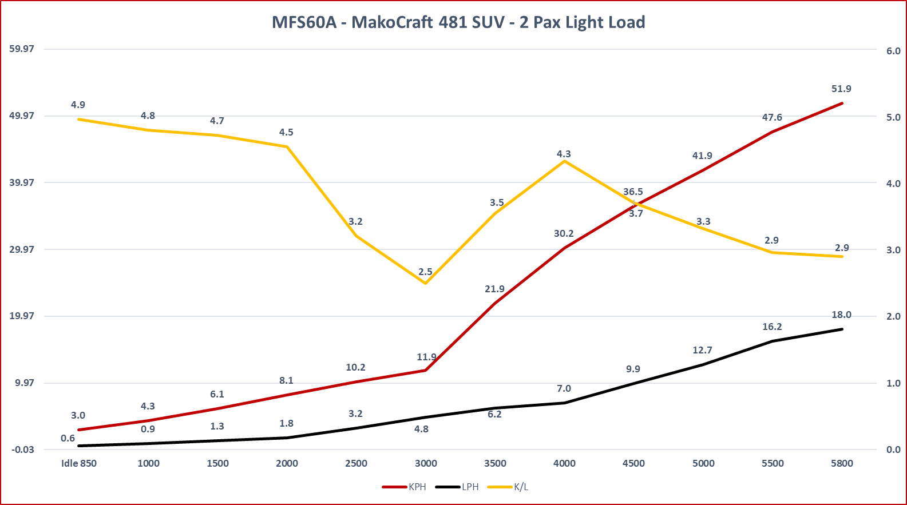

* **MFS60A ET L**
* **Configuration 3 cylinder – 12 valve, roller rockers**
* **Displacement 866cc (52.8 cu in)**
* **Bore & Stroke 75 x 75mm (2.76 x 2.95in)**
* **Gear Ratio 2.08:1**
* **Propeller pitch 11x14 STD Alloy**
* **Transom height 20”**
* **Fuel Unleaded petrol (87 octane)**
* **RPM Range 5000 – 6000**
* **Alternator 12V 252W (21A)**
* **Weight 20” shaft - 98.5 kg**
* **Boat 4850mm LOA, Beam 2200mm**
* **Hull Alloy - 3mm bottom, 3mm sides**
* **Boat Load Hull 440kg + 2 pax, fuel, motor,**
* **Weight as tested 780kg**
* **Fuel Tank 60L**
* **Conditions Salt Water, Top of tide, 10knts SE**
* **Water Temp 22.8 c**
* **Air Temp 26 c / 71% Humidity**