**MFS140A – Carbine 600**

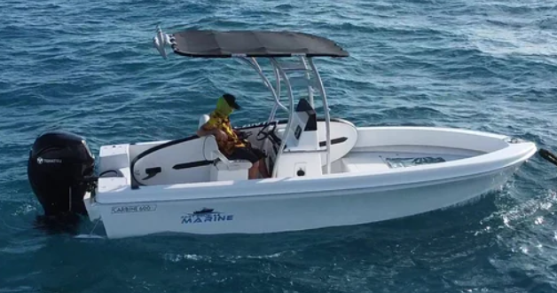 

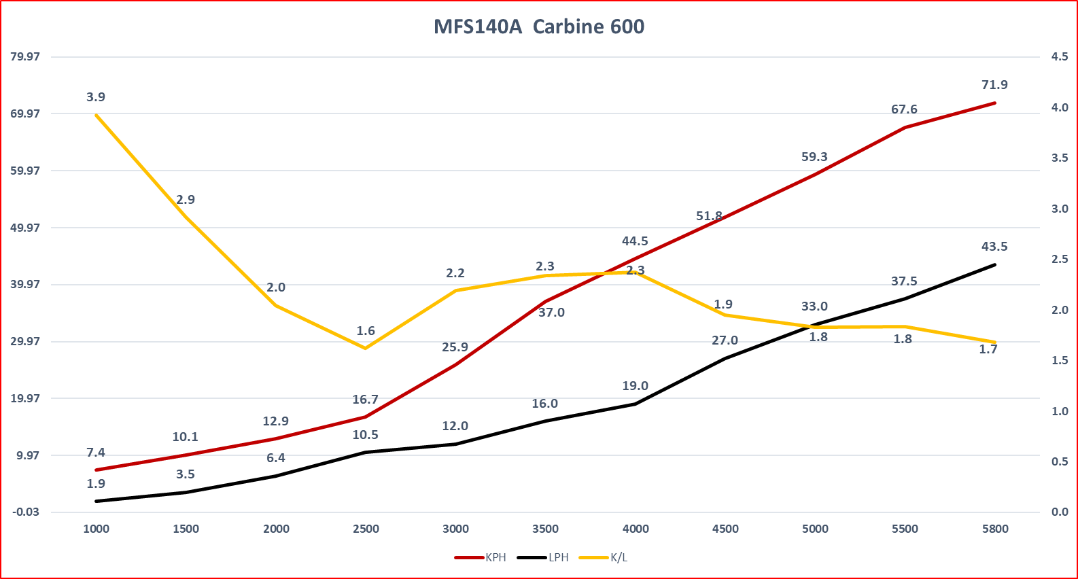

* **MFS140A ET UL**
* **Configuration 4 cylinder – tuned length exhaust 4-2-1 design**
* **Displacement 1995cc (91.29 cu in)**
* **Bore & Stroke 84 x 90mm (3.31 x 3.54in)**
* **Gear Ratio 2.08:1**
* **Propeller pitch 14 x 19 SS Torquemaster 4 blade**
* **Transom height 25”**
* **Fuel Unleaded petrol (95 octane)**
* **RPM Range 5000 – 5800**
* **Alternator 12V 492W (41A)**
* **Weight 25”183 kg**
* **Boat 6000mm LOA, Beam 2150mm**
* **Hull 23deg Fiberglass**
* **Boat Load Hull 700kg + 2 pax = 140kg + fuel + motor + S Gear**
* **Weight as tested 1300kg**
* **Fuel Tank 240 Litres**
* **Conditions Salt Water, Fine - 5knts**
* **Water Temp 23 c**
* **Air Temp 24 c / 75% Humidity**