**2 x MFS140A – Marlin Broadbill 6.1**

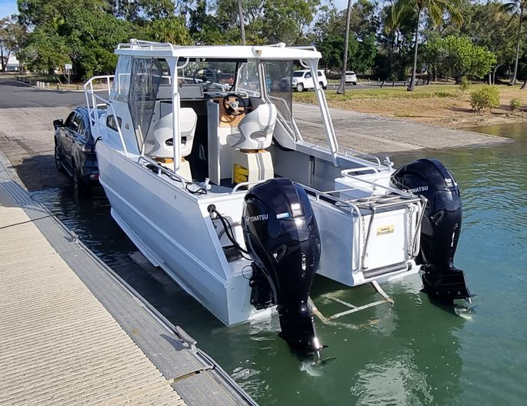 

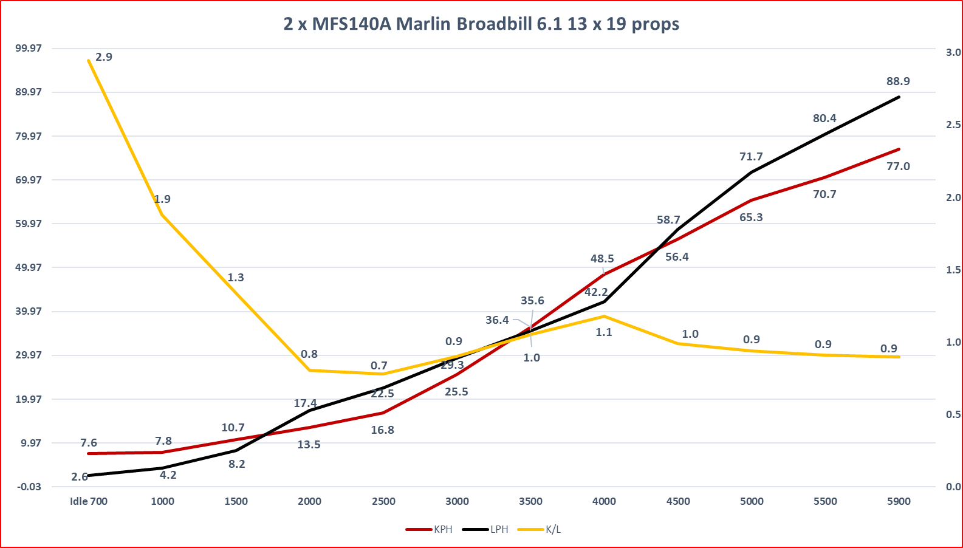

* **2 x MFS140A ET UL**
* **Configuration 4 cylinder – tuned length exhaust 4-2-1 design**
* **Displacement 1995cc (91.29 cu in)**
* **Bore & Stroke 84 x 90mm (3.31 x 3.54in)**
* **Gear Ratio 2.08:1**
* **Propeller pitch 13 x 19 SS Genesis 4 blade**
* **Transom height 25”**
* **Fuel Unleaded petrol (95 octane)**
* **RPM Range 5000 – 5800**
* **Alternator 12V 492W (41A)**
* **Weight 25”183 kg**
* **Boat 6100mm LOA, Beam 2450mm**
* **Hull Twin Hull Aluminium**
* **Boat Load Hull 2100kg + 3 pax = 280kg, fuel, motors, S Gear**
* **Weight as tested 2500kg not confirmed**
* **Fuel Tank 240 Litres approx**
* **Conditions Salt Water, Fine - 5knts**
* **Water Temp 21 c**
* **Air Temp 21 c / 43% Humidity**